Lab 5 Notes
Resistance to Linear Fitting
Date: Oct 21, 2025
Lab Group: Lourdes Z., Melody I., Abdon M.

Part 1
Methods
In this lab we will be testing if linear models will be able to accurately describe electrical effects in the real world. We will be using the $χ^{2}$technique to determine if the model is accurate or not. For Part 1, we are determining if different materials obey ohmic relations or not. To test this we will be using banana wires, a rheostat, lightbulb, Extech power supply, and a digital multimeter. When making our circuit we decided that we would be measuring current and confirming the measurement with the digital multimeter to ensure the Extech readings are correct. We measured the current starting at 5 Volts and increasing with every Volt until reaching12 Volts. We began with measuring the current (A) of the rheostat then the lightbulb, following the same procedure for both. The rheostat is designed to be ohmic, so we will be able to compare our results for the lightbulb to the rheostat’s graph. We are predicting that the lightbulb will be ohmic.We will plot current versus voltage for each component and determine linearity using the slope (R = V/I). A straight-line fit would indicate ohmic behavior. So, with this prediction the graph would follow a linear model.
- Equipment/Experimental Systems
  - Extech Power Supply- used to adjust voltage and measure current
  - Digital Multimeter- used to confirm current measurements
  - Rheostat- resistor
  - Lightbulb- emitting light that will confirm circuit is connected
- Variables
  - Independent variable: Voltage
  - Dependent variable: Current
  - Constant variables: Experimental equipment, voltage increments
- Statistical and Analytical Tools
  - Linear fitting
  - Chi-squared parameter
    - $χ^{2}=\frac{1}{N-d}$$\sum_{i=1}^{N}{}\frac{(y-f(x))^{2}}{δy^{2}}$
Data
Device | V (voltage) | I (current) | Uncertainty for V | Uncertainty for I | R (resistance) | Propagated Uncertainty of R
Lightbulb | 5 | 0.698 | 0.01 | 0.002 | 7.163323782 | 0.02503078254
 | 6 | 0.758 | 0.01 | 0.002 | 7.915567282 | 0.02470313793
 | 7 | 0.822 | 0.01 | 0.002 | 8.515815085 | 0.0240271929
 | 8 | 0.873 | 0.01 | 0.002 | 9.163802978 | 0.02391551617
 | 9 | 0.928 | 0.01 | 0.002 | 9.698275862 | 0.02351574135
 | 10 | 0.978 | 0.01 | 0.002 | 10.22494888 | 0.02327604267
 | 11 | 1.025 | 0.01 | 0.002 | 10.73170732 | 0.02310111581
 | 12 | 1.071 | 0.01 | 0.002 | 11.20448179 | 0.02291221497
Rheostat | 5 | 0.032 | 0.01 | 0.002 | 156.25 | 9.770623721
 | 6 | 0.038 | 0.01 | 0.002 | 157.8947368 | 8.31441493
 | 7 | 0.044 | 0.01 | 0.002 | 159.0909091 | 7.234975506
 | 8 | 0.051 | 0.01 | 0.002 | 156.8627451 | 6.154604407
 | 9 | 0.057 | 0.01 | 0.002 | 157.8947368 | 5.542943287
 | 10 | 0.064 | 0.01 | 0.002 | 156.25 | 4.88531186
 | 11 | 0.069 | 0.01 | 0.002 | 159.4202899 | 4.623150135
 | 12 | 0.075 | 0.01 | 0.002 | 160 | 4.268749492
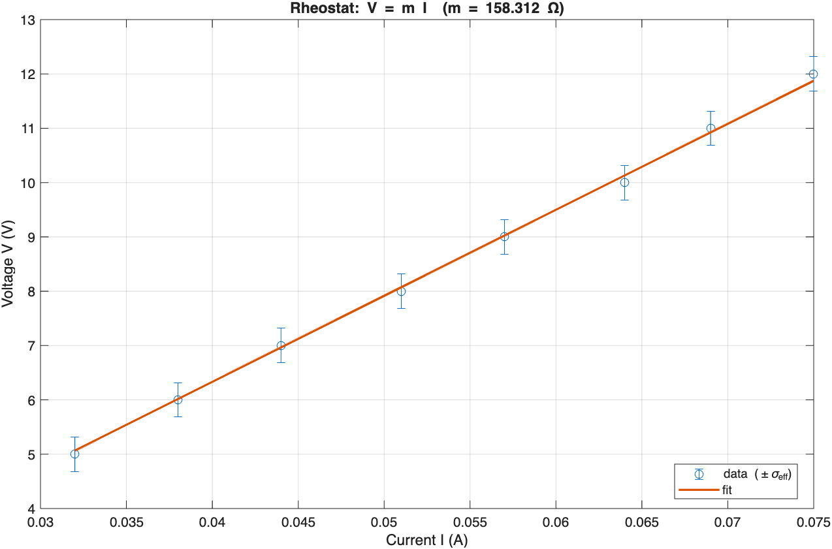
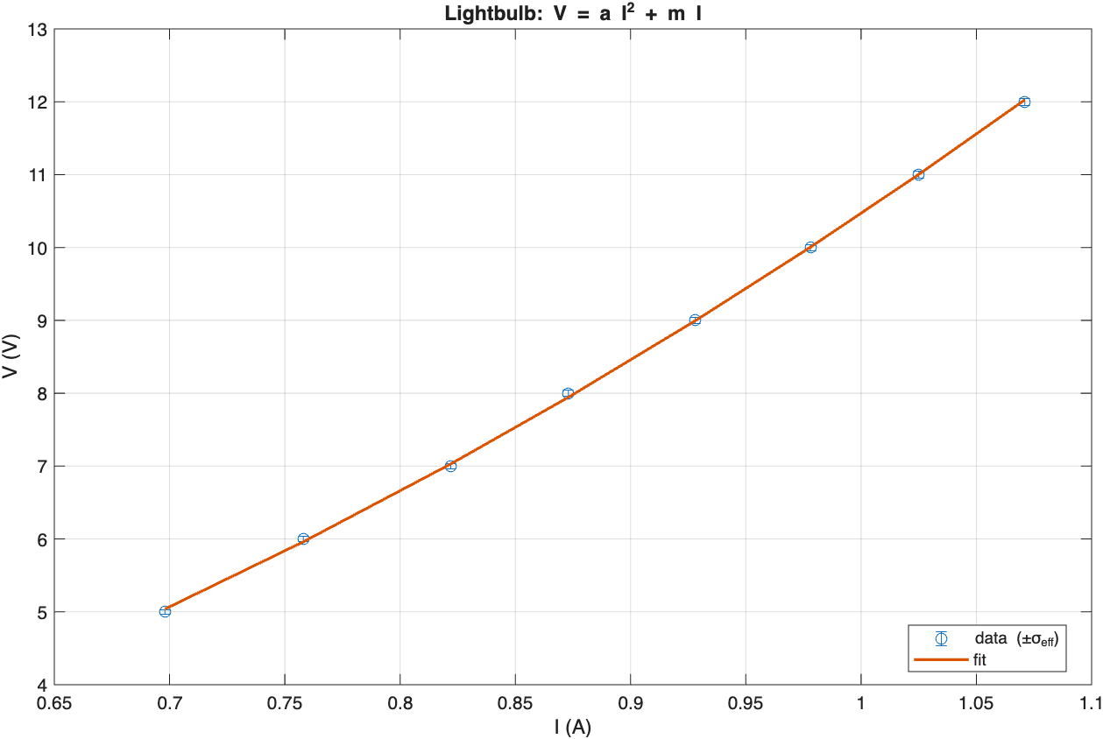
Data Output:
For the linear model (Rheostat):
>> linearModel_Rheostat
V = mI: m = 158.312 ohms
chi2 = 510.996, dof = 7, red chi2 = 72.999, p = 0.000
For the quadratic model (Lightbulb):
>> quadModelA_Lightbulb
Model V = a I^2 + m I
a = 10.751 ± 0.13 V/A^2
m = -0.285461 ± 0.12 ohms
chi2=6.040, dof=6, red chi2=1.007, p=0.419
Conclusion
Based on our results, the rheostat presented a linear relationship between the voltage and the current supporting that it is ohmic following the model $ΔV=IR$. However, for the lightbulb, we concluded it to be non-ohemic. The Lightbulb failed to exhibit a linear relationship between voltage and current but instead showcased a quadratic relationship as it passed the first quadratic model of $y=ax+bm$. As voltage increased, there was clear evidence of the resistance also increasing which may have been due to the temperature resulting from the lightbulb. The temperature the lightbulb gives off plays a role in what differentiates it from the ohmic model presented in the rheostat as it did not give off temperature rises. The $χ^{2}$value (chi-square value) was much larger which indicated that it did not fit the Ohmic model, but rather the non - ohmic model.
In future iterations, we could
- Take smaller voltage intervals which would represent a better trend visualization
- Measure the filament temperature to visualize the direct effect temperature has on the model
- Take several measurements of the slider position on the rheostat to reduce human error on the calculations

Part 2
Methods
For Part 2, we will be testing if the relationship of the following equation is accurate for the rheostat: $R=cL$. To do this we will be utilizing the D battery in our circuit instead of the Extech. Everything else in the circuit will remain the same, the lightbulb, rheostat, digital multimeter, and the D battery will all be connected. We will be keeping the voltage at 6 V for all lengths. To measure this relationship we are recording the current at increasing intervals of 1 inch. To perform this, we will be using a measuring tape, rheostat, D battery, banana cables, lightbulb, and a digital multimeter. We will calculate resistance (R = V/I) for each length and plot R versus L to determine if the data follow a linear relationship, as predicted by R=cL. We are predicting that a longer length (L) will make a large R, proving the rheostat an accurate resistor.
- Equipment/Experimental Systems
  - D batter- Power source that maintains a voltage of 6 V
  - Digital Multimeter- used to confirm current measurements
  - Rheostat- resistor
  - Lightbulb- emitting light that will confirm circuit is connected
  - Measuring tape- to measure the length of the rheostat
- Variables
  - Independent variable: Length of the rheostat (L)
  - Dependent variable: Resistance (R)
  - Constant variables: Voltage (V), experimental equipment
- Statistical and Analytical Tools
  - Linear fitting
  - Chi-squared parameter
    - $χ^{2}=\frac{1}{N-d}$$\sum_{i=1}^{N}{}\frac{(y-f(x))^{2}}{δy^{2}}$
Data
L (inches) | V (voltage) | I (current) | R (resistance) | Uncertainty for I | Propagated Uncertainty for R
0 | 6 | 0.017 | 352.9411765 | 0.002 | 47.7257845
1 | 6 | 0.02 | 300 | 0.002 | 36.05551275
2 | 6 | 0.025 | 240 | 0.002 | 24.99279896
3 | 6 | 0.033 | 181.8181818 | 0.002 | 16.38134297
4 | 6 | 0.048 | 125 | 0.002 | 9.827063679
5 | 6 | 0.086 | 69.76744186 | 0.002 | 4.926034629
6 | 6 | 0.736 | 8.152173913 | 0.002 | 0.5439295541
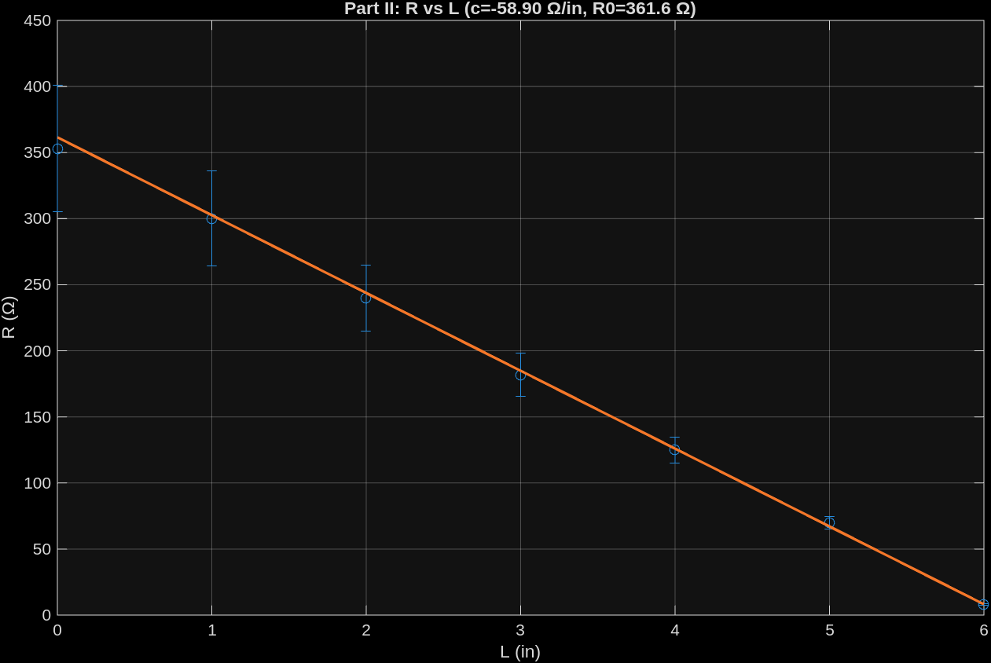Data Output:
=== Part II: R vs L (dump) ===
Using V=6.0 V, sigmaV=0.4 V, sigmaI=0.002 A

MODEL A: R = c L
c = 1.52877 ± 0.0902 ohm/in
chi2 = 639.066, dof = 6, reduced chi2 = 106.511, p = 0.000

MODEL B: R = c L + R0
c = -58.8964 ± 2.39 ohm/in
R0 = 361.554 ± 14.3 ohm
chi2 = 0.406, dof = 5, reduced chi2 = 0.081, p = 0.995
==============================================
Conclusion
Based on our data, $R=cL$ does not hold because there is a negative relationship rather than a positive one as demonstrated in the model As resistance $L$ increased from 0-6 inches, $R$ decreased, showcasing a negative linear relationship between resistance and the length of the rheostat. Moving the slider would decrease the length of the wire which would in turn increase resistance which is the expected behavior and aligns with what was found. As showcased in the graph figures above, plotting $R vs L$ demonstrated a linear relationship between resistance and length of wire, however there was a negative slope. When looking at the value for $χ^{2}$ it is much larger than 1 for Model A, so it is not going to explain the data as well. For Model B we do see a $χ^{2}$ less than one, so we can say that it is consistent with the model. The relationship wasn’t perfectly linear which may have also resulted due to errors such as measurement errors when measuring the Length of the wire as it was rather difficult to use the ruler to accurately measure what L was. This could’ve led to inconsistencies in the data, skewing the data.
In future iterations we could
- Use different methods to measure what L would be
- Perform multiple trials for each position to account for possible human errors when measuring
- Using a wider range of L to determine its clear effect on R.

